※ |  | Competition Guidelines

H  O  W  T  O  A  P  P  L  Y | Title |  | OPEN SEOUL, The < KONNEXCHEON Pavilion> Global Video Open Call 2025
H  O  W  T  O  A  P  P  L  Y | Eligibility |  | Open to anyone, regardless of nationality.
H  O  W  T  O  A  P  P  L  Y | Theme |  | ○ Twenty years ago, Cheonggyecheon began its restoration and has since been reborn as a world-renowned space in the heart of Seoul—a place where nature and citizens coexist in the center of the city. To celebrate this transformation, we invite video submissions that explore the past, present, and future of the city, inspired by the boundless possibilities symbolized by Cheonggyecheon.  ○ At the newly built <KONNEXCHEON Pavilion>, two facing screens display nightly projections that freely express visions of Cheonggyecheon, Seoul, and cities around the world—imagining their futures through diverse creative perspectives.  ○ Bringing together images of cities, eras, and imaginations, this open call invites everyone to envision better cities of tomorrow. Through narratives where reality and imagination intersect, the project offers citizens a unique opportunity to take the lead in reimagining the city.  • Imaginative reinterpretations of Cheonggyecheon, Seoul, or urban life in general  • Narratives blending past and future, reality and fiction  • Civic imagination that envisions the city’s potential and transformation  • Expressions that freely navigate between fact and fantasy, documentation and  Fiction
H  O  W  T  O  A  P  P  L  Y | Exhibition Period |  | Starting from December 2025 (schedule varies by work)
S  U  B  M  I  S  S  I  O  N | Open Call  Period |  | October 27 (Mon) – November 23 (Sun), 2025
S  U  B  M  I  S  S  I  O  N | Submission  Period |  | November 1 (Sat) – November 23 (Sun), 2025 (until 23:59 KST)
S  U  B  M  I  S  S  I  O  N | How to  submit |  | Email submissions: konnexcheon@gmail.com
S  U  B  M  I  S  S  I  O  N | Materials | 1.  Required  documents | 1. Application Form (Form 1)  2. Consent Form (Form 2)  3. Work Description (Form 3)
S  U  B  M  I  S  S  I  O  N | Materials | 2.  Work requirements | Video and Image (No restrictions on medium: video, photography, painting, etc.)  - Format: 16:9 ratio (landscape orientation)  - File Type: mp4 (H.264) recommended, jpg, etc. / Video input via HDMI / OS compatible  - Resolution: FHD (1920×1080) or higher (screen size: 6.115m × 3.425m)  - Duration: Minimum 15 seconds – Maximum 20 minutes  - File Size: Under 2GB  - File Name: ParticipantName(TeamName)_WorkTitle  ※ Images may be edited and converted into video format.  ※ Winners may be asked to provide the original high-resolution file after selection.
S  E  L  E  C  T  I  O  N | Selection  Process |  | ※ Screening period and schedule will be announced later only for the selected works.
  Open Call | ⇨ | Evaluation & Selection | ⇨ | Screening
  Oct 27 – Nov 23, 2025 |  | Nov 24 – Nov 28, 2025 |  | December 2025
S  E  L  E  C  T  I  O  N | Evaluation  Period |  | November 24 (Mon) – November 28 (Fri), 2025
S  E  L  E  C  T  I  O  N | Evaluation  Method |  | Document Review
S  E  L  E  C  T  I  O  N | Evaluation  Criteria |  | Relevance to theme, Creativity, Public engagement
S  E  L  E  C  T  I  O  N | Judging  Panel |  | Director of Design Policy, Exhibition Director, OBRA Architects ※Subject to change
S  E  L  E  C  T  I  O  N | Selected  Works |  | 40
S  E  L  E  C  T  I  O  N | Prizes |  | KRW 200,000 each
N  O  T  E  S | Important  Information |  | ※ Winning works may be used for exhibition, screening, and promotional purposes.  ※ All submissions must be the artist’s own original creation. Even after final selection, if any issue of plagiarism or imitation arises, the award may be canceled.  ※ Previously created works may be submitted; however, works that are similar to existing ones will be excluded from evaluation, and if such similarities are discovered after selection, the award will be withdrawn.  ※ Works must be produced and edited with content suitable for public exhibition and display, considering the screen size (width 6.115m × height 3.425m) and the public nature of the venue.  ※ Entrants are fully responsible for ensuring their works are original and do not infringe on any intellectual property rights (including copyright, music copyright, portrait rights, etc.). If any infringement or plagiarism is discovered after selection, the production (creation) cost will be fully reclaimed, and the award may be canceled.  → Works created using generative AI may be submitted; however, the use and source must be clearly stated, and all legal responsibilities related to intellectual property rights rest solely with the entrant.  ※ Selected artists will enter into an agreement within the designated period, granting permission for their video and image works to be used for exhibitions and promotional purposes serving the public interest.  ※ Due to the characteristics of the display platform, works containing thin lines, delicate details, or low-saturation colors may not appear clearly. (It is recommended to use high-saturation colors and bold lines when creating works.)  ※ Each team may submit multiple works. However, in the event of multiple selections, only the highest-ranking award will be granted (no duplicate awards).

1. Application Form (Form 1)

OPEN SEOUL, The <KONNEXCHEON Pavilion> Global Video Open Call 2025
1. Application Form

Basic Information
Name
Date of Birth | (YYYY.MM.DD) ※ For Name Duplicate Verification
Contact | Phone  Email  Address
Field of Work  (Occupation) | □ Video Artist | □ Artist | □ Student in  Related Major | □ General  Public
Participant’s Key
Career/Experience
I hereby apply for the OPEN SEOUL, The <KONNEXCHEON Pavilion> Global Video Open Call 2025, having read and understood the details of the call.

- The information you provide will be used solely for the purpose of conducting the competition and will be discarded after the exhibition is completed.
- If you are participating as a team, please fill in the team leader’s information under ‘Basic Information’ and list all team members in the ‘Team Members (Participants)’ section. If you are participating individually, you do not need to fill out the ‘Team Members (Participants)’ section.

Date: _________________________________

Applicant: _______________________ (Signature)

To: Mayor of Seoul Metropolitan Government
※ Required Documents
1. Application Form / 2. Consent Form / 3. Work Description / 4. Video Work
\

2. Consent Form (Form 2)

OPEN SEOUL, The <KONNEXCHEON Pavilion> Global Video Open Call 2025
2. Consent Form

I hereby agree to comply with all conditions regarding OPEN SEOUL, the <KONNEXCHEON Pavilion> Global Video Open Call 2025 organized by the Seoul Metropolitan Government and submit the relevant documents as follows:

- I will comply with all conditions of the open call set by the Seoul Metropolitan Government and submit all required documents truthfully. I understand that any false or exaggerated statements may result in disadvantages or disqualification.

- I declare that the submitted work is an original creation made and, does not use another party’s copyrighted material, and that I accept full responsibility for any related copyright issues.

- I have reviewed the evaluation criteria and procedures set by the Seoul Metropolitan Government and will not raise objections to the composition of the judging panel, evaluation methods, or results.

- The copyright of the submitted work remains with the participant. However, the Seoul Metropolitan Government retains the right to use the work for non-commercial purposes such as exhibition, documentation, and promotion, without objection.

Date : __________________

Applicant: _______________________ (Signature)

To: Mayor of Seoul Metropolitan Government
3. Work Description (Form 3)

OPEN SEOUL, The <KONNEXCHEON Pavilion> Global Video Open Call 2025
3. Work Description

Title

※ Please write up to 2 pages, 12pt Arial font. Additional pages may be attached if necessary.

※ |  | Appendix. Project Overview

■ OBRA Architects <KONNEXCHEON Pavillion>
The 23rd bridge of Cheonggyecheon and a creative gathering space for citizens
The KONNEXCHEON Pavillion marks the 20th anniversary of Cheongyyecheon rebirth. Acting as a 23rd bridge added to the existing 22nd, it celebrates Cheongyyecheon as one of Seoul’s most beloved public spaces. Open to all, as a place of encounter and personal exchange, the KONNE><CHEON Pavilion aims to fulfill the democratic urban promise of life shared and enjoyed in community. During the day, the Pavilion serves as a space of free open use for all, including not only chance encounters and maybe a place to share a casual lunch but also a place of impromptu performance and random planned gatherings of any kind. In the evenings—under the theme “Coexistence: The City,” video projections produced by people like you, appear on the north and south screens as part of an opportunity of expression open to all. Anyone can take part in the screening through the website during the exhibition period.

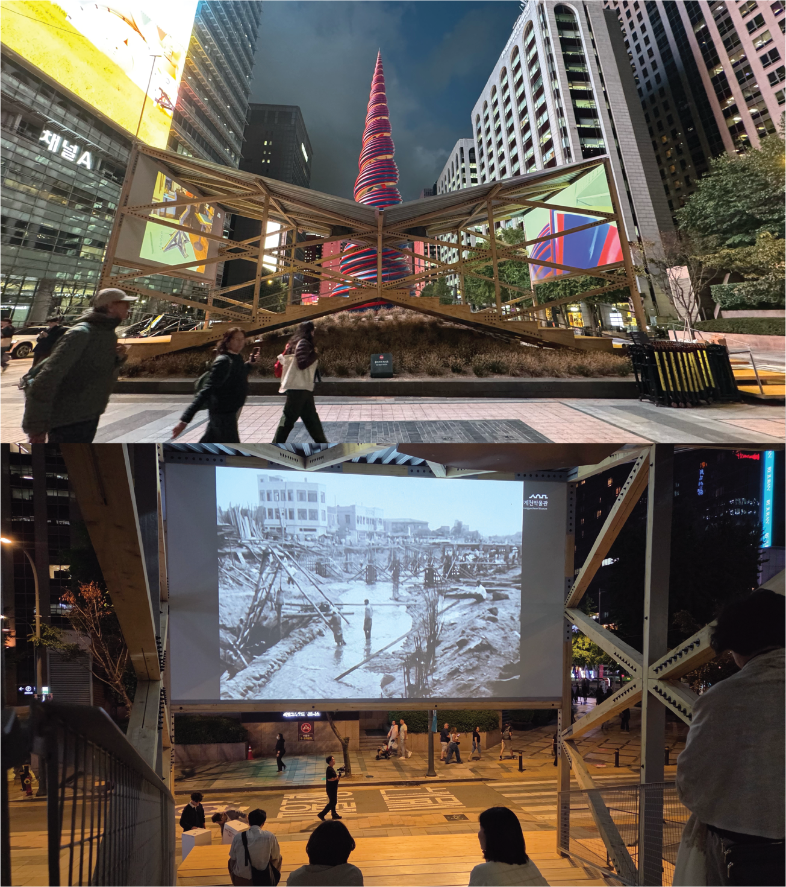

■ 2025 Cheonggyecheon Public Art Project – Inter-Flow Cheonggye

In 2025, marking the 20th anniversary of the Cheonggyecheon Restoration, the public art project <Inter-Flow Cheonggye> unfolds across Cheonggye Plaza and the Cheonggyecheon area. Featuring both established and emerging artists from Korea and abroad, the project presents a new era of public art that bridges the past and present of Cheonggyecheon.
Cheonggyecheon has long been a unique place where tradition and modernity, people and nature coexist in harmony. Like the continuous flow of its waters, this project demonstrates how art, too, can move, change, and coexist with the citizens who share its space.

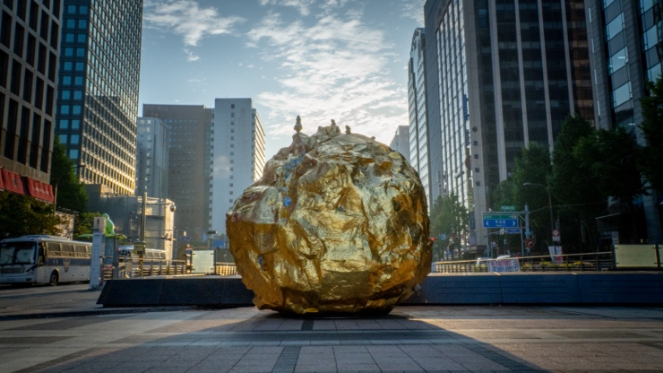 | 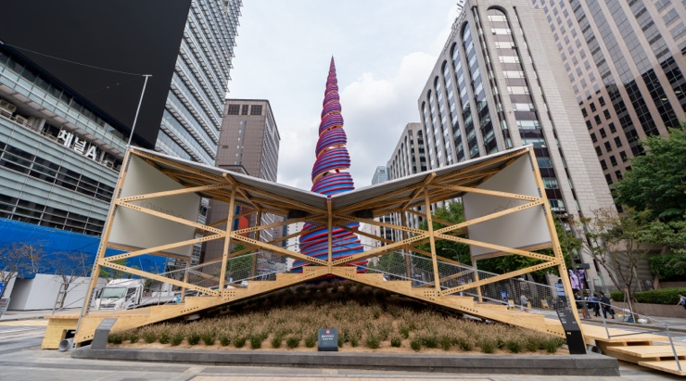
You Were There_Cheonggyecheon 2025  Yeesookyung | KONNEXCHEON Pavilion  OBRA Architects
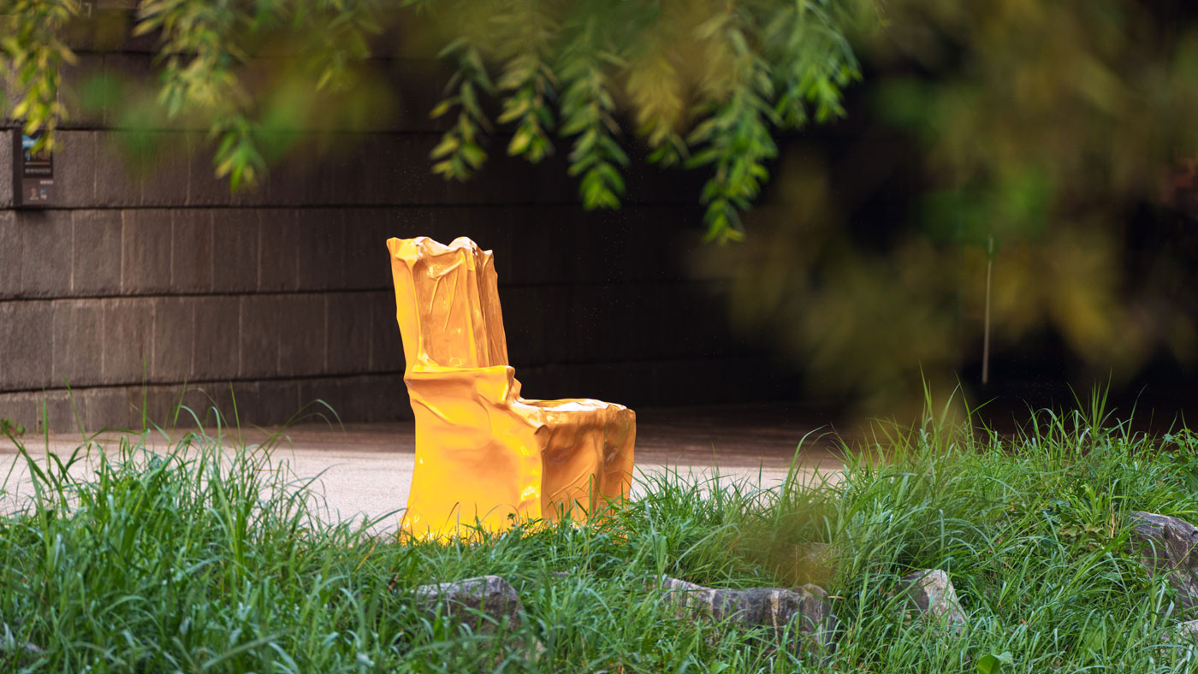 | 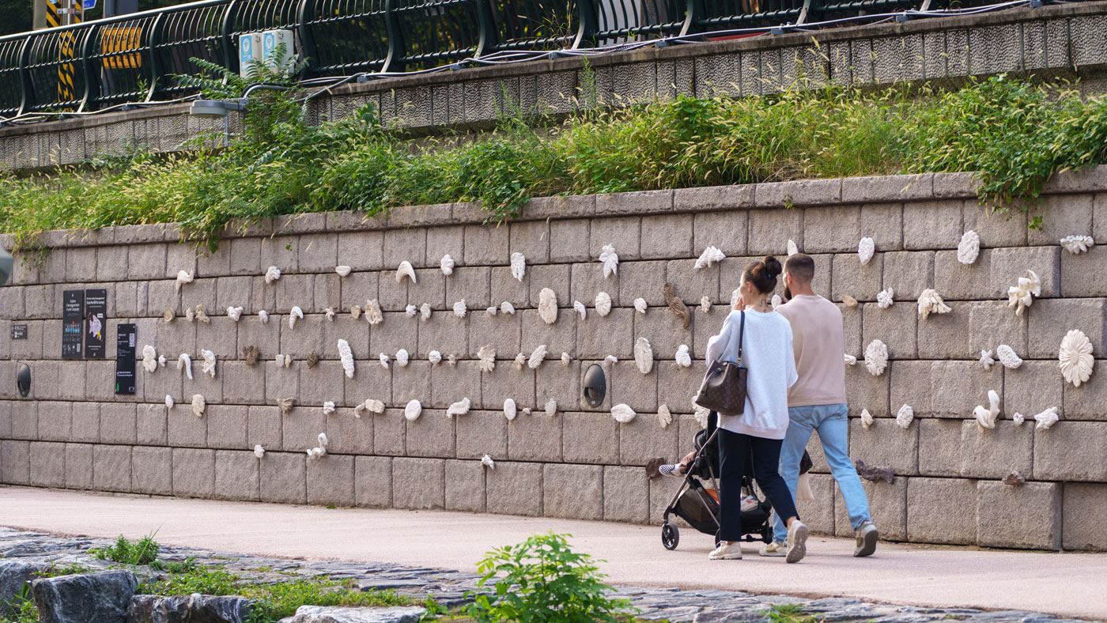
Where Memory Rests  Jang Seungtae | Cheonggye Green:Noongil Songil  Jeon Youngeun
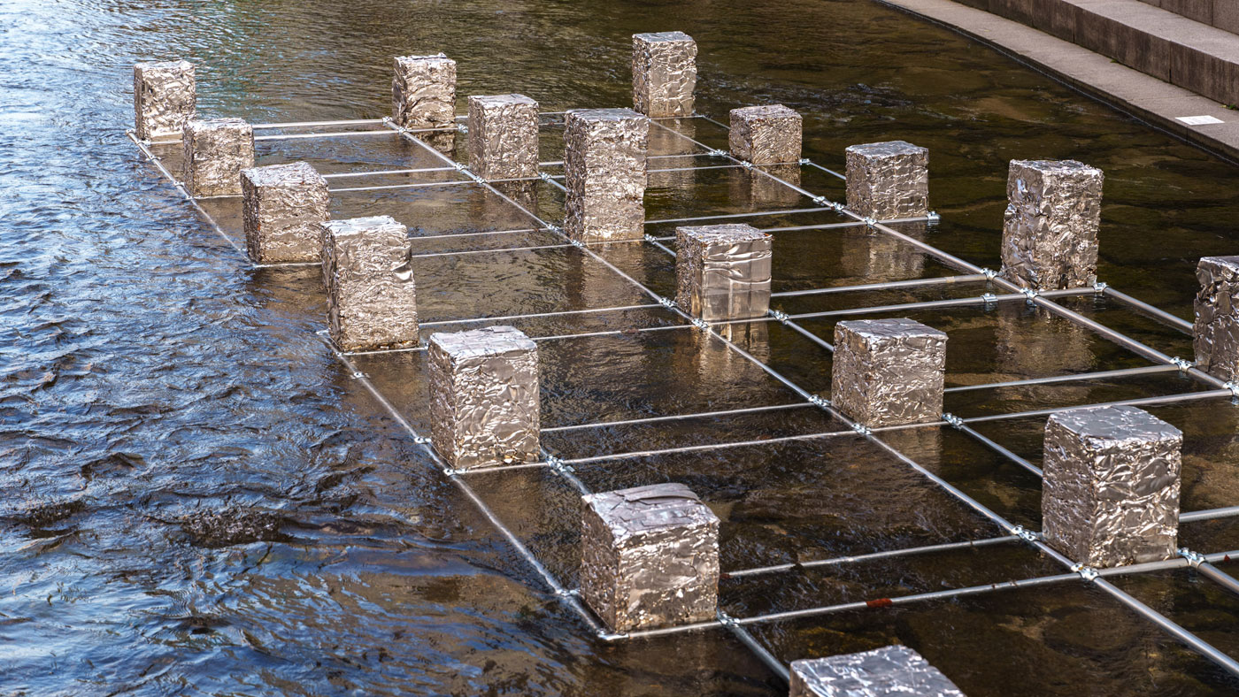 | 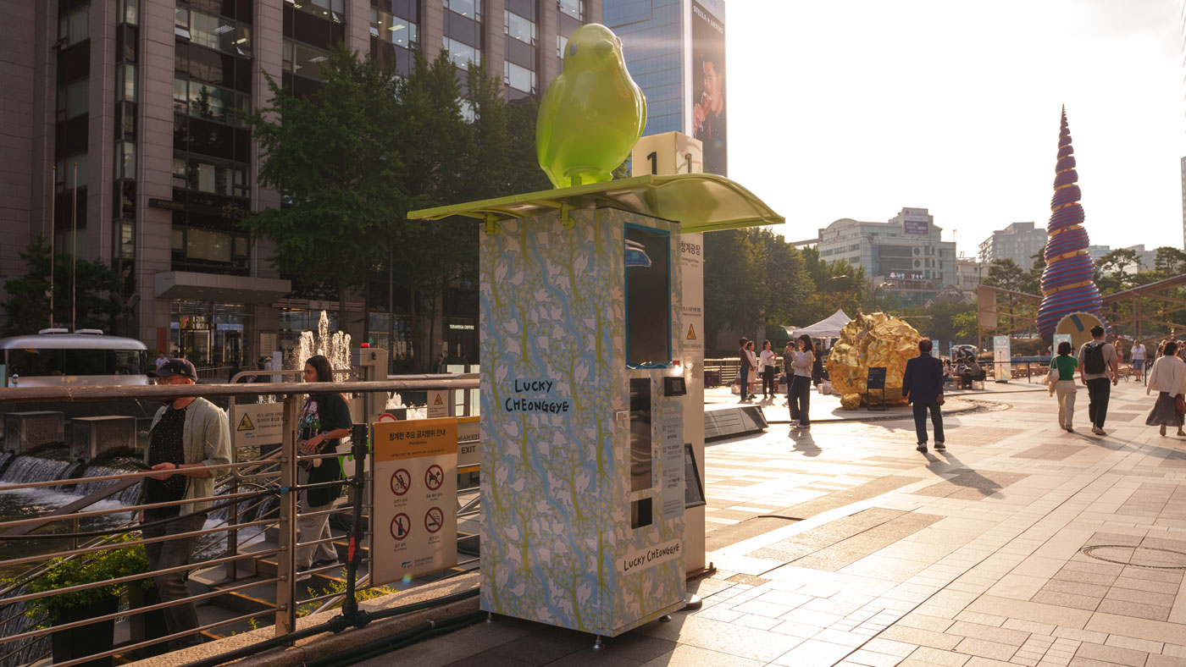
Cheonggye Yu-Seok  Lim Keunyoung, Jeon Jaebong | Cheonggyecheon Encounters  Lim Jungmin

